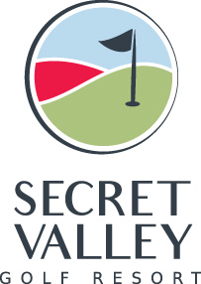

24th August, 2021

Dear Secret Valley Golf Club Member
Despite frequent requests to relevant governing bodies, we still have not been given approval to re-open our showers for use by members or guests.
It appears the major concern of the Health Department is the possibility of Covid-19 virus being transmitted via the steam created by use of showers
I sincerely apologise for this on-going inconvenience. However, as soon as we are allowed, we will re-open shower facilities, even if as a first stage, we only offer to members with a bring your own towel policy.
Stay safe and hopefully, cooler weather will be with us soon.
Peter Copping
General Manager

