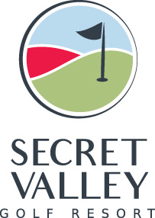

Dear Secret Valley Members,

With the festive season rapidly approaching we would like to take this opportunity to inform you of this year’s Christmas Charity.
Over the past few years many of you have been extremely generous by providing gifts which were donated to the Theoskepatsi Special needs school in Paphos.
This year we have chosen to donate to the Paphos Ukrainian Refugee centre. Some of our members are directly involved with volunteering at the centre and we feel that this is an extremely worthy cause. The centre is currently home to more than 150 children who range in age from 3 months to 16 years old.
Any donations will be greatly appreciated however, in an effort to collect items that the Children really need the centre has provided us with a wish list and have also asked that any gifts donated are labelled with either Boy or Girl and which age range they are appropriate for.

- Socks
- Blankets
- English language childrens books
- Practical actives/ Games
- School stationary
- Sweets
- Slippers
- Warm clothing

We are hoping to deliver all gifts to the children on the 22nd of December therefore we would like to ask that any gifts that you wish to donate are placed underneath the Christmas tree in the clubhouse before that date.
Thank you in advance.

Adam Collinson
Director of Golf

